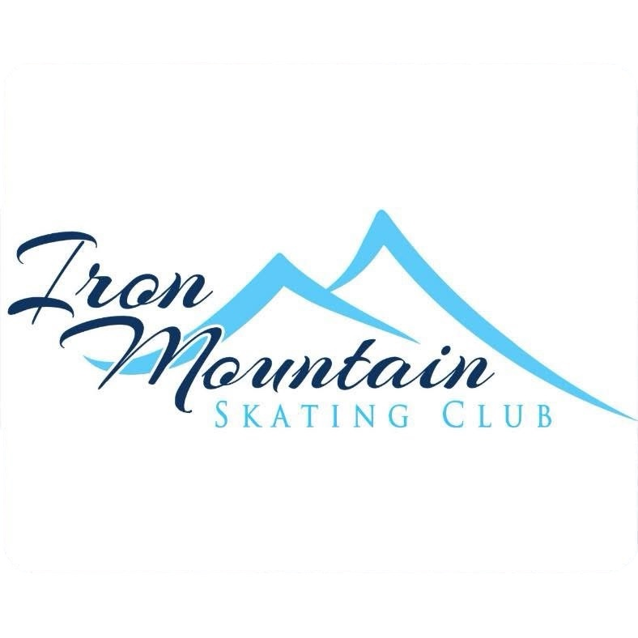

Iron Mountain Skating Club
Sponsorship/Donation Form

To Whom It May Concern,
On behalf of the Iron Mountain Skating Club, we are excited to invite you to support our upcoming figure skating event, Be the Light, taking place on March 21st & 22nd at Mountain View Ice Arena.
This event will bring together approximately 75 local skaters of all ages and skill levels, along with families, coaches, and community members, for a weekend celebrating athleticism, artistry, and sportsmanship. Your support will play a vital role in helping us create a memorable and successful event while keeping participation affordable for our skaters.
We are currently seeking support in several ways:
Sponsorship Opportunities
We offer a variety of sponsorship levels, each of which includes recognition in our event program and other promotional opportunities. Program advertising options are available in multiple sizes to fit your marketing needs and budget.
In-Kind Donations
In-kind contributions such as goods, services, or gift certificates help offset event expenses and are greatly appreciated. These donations will be acknowledged in our event materials.
Raffle Donations
Raffle items are a highlight for our attendees and an excellent way to showcase your business. Donors will receive recognition during the event in our program.
Supporting Be the Light provides valuable exposure to a broad local and regional audience while demonstrating your commitment to youth development and community sports. We would be happy to tailor a sponsorship or advertising package that best suits your organization.
Thank you for considering this opportunity to support our figure skating community. We would be delighted to discuss this further or provide additional details at your convenience.
Warm regards,
Iron Mountain Skating Club

Iron Mountain Skating Club
Sponsorship/Donation Form

Sponsorship Opportunities:

$25.00 - ¼ page advertisement in our event program
$50.00 - ½ page advertisement in our event program
$100.00 - full page advertisement, includes any skater mentions by name, in our event program

In-Kind Donation Value:$___________________

Raffle Donation Value:$____________________

Business Name:________________________________ Contact:___________________________

501(c)3

